Association for Ex-Sainik School Puruleans
(A Registered Association under the West Bengal Societies Act XXVI of 1961)

SAINIK SCHOOL PURULIA, P.O:SAINIK SCHOOL, Dist:PURULIA, Pin:723104,
Phone:

West Bengal, India.
Email: secretary.esspeans@gmail.com

TENDER DOCUMENTS
( FOR CONSTRUCTION OF ONE PHYTORID TANK)
Reference: TN. No: Phy/2022/01 Dated: 30.11.2022

Association for Ex Sainik School Puruleans (ESSPEANS) C/O Sainik School Purulia invites Tender under “Swachch Bharat Programme” from reliable, resourceful, bonafide and experienced firms /companies/ individual contractors/Joint Ventures/Consortium, who have successfully completed the work of similar nature of works within the last 7 (seven) years from the date of this NIT in any Govt. / Semi-Govt. / Govt. Undertakings / Autonomous Bodies / Statutory Bodies and Local Bodies is eligible for the under mentioned works.

Sl.  No. | Name of the Work | Estimated Project Cost | EMD | Period
1. | Construction of one Phytorid Tank out of Five with capability to screen, sediment, process and store treated water as per specification using Phytorid Technology. Construction site will be indicated by the user at Sainik School Purulia. Construction will include Final Inspection, Successful Trial Run and Six Months of uninterrupted functioning as per laid down standards. | RS. 10 Lakhs | Rs. Ten thousands. | 06 Months
Corrigendum/Addendumifanywouldbepublishedonthewebsiteonly. Design and Scope of Work
Process Flow Diagram
Treated Water Tank
Phytorid Bed
Sedimentation Tank
Screen Chamber

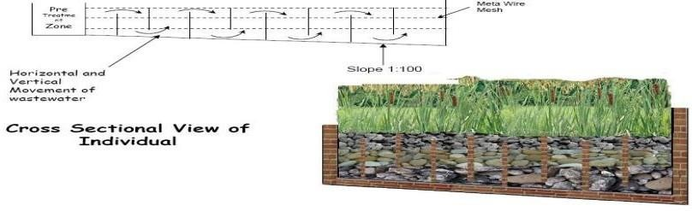
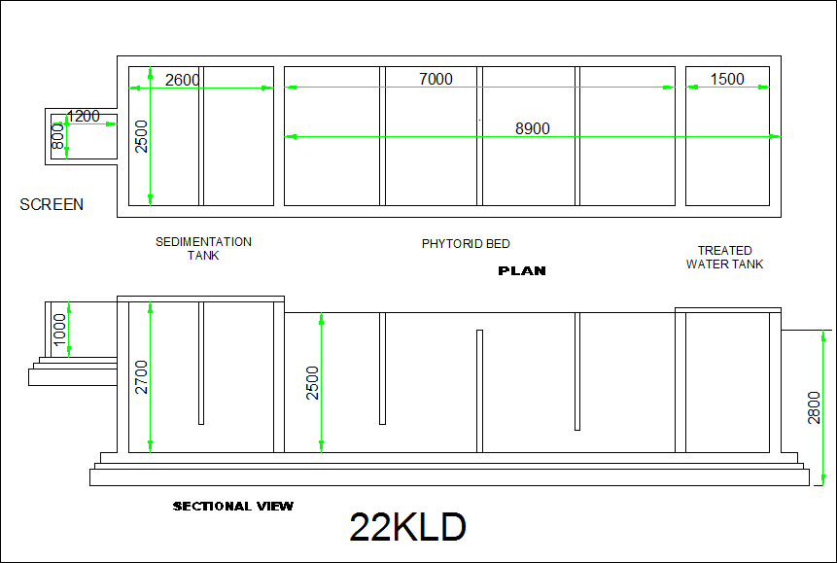

TECHNICAL SPECIFICATION AND SCOPE OF THE WORK

Objective:
The main objective of the proposed wastewater treatment is to provide a simple, feasible, eco-friendly and cost-effective technology. The proposed technology has negligible operation and maintenance costs.
The technology has following key features:

- Being based on natural treatment process, external source of aeration is not required, hence negligible consumption of electric power.
- The technology is very simple in design and operation, therefore, needs no skilled manpower for operation and maintenance.
- The system has an aesthetic aura because of plants (ornamentals well as flowering) and subsurface flow of water.
- The production of sludge is negligible with no odor issues.
- The Phytorid bed is custom designed as per the land availability.
- There is no application of chemicals for treatment process.

Building and equipment components for Phytorid based wastewater treatment technology:
Phytorid unit is essentially a civil structure. It comprises of screen chambers, collection chamber, Phytorid bed, treated water tank.
    - Screen Chamber: Raw water consists of coarse and fine solid particles, to remove that by using bar screens of 5 mm and 3 mm aperture size for coarse and fine particles respectively.
    - Collection cum Sedimentation Tank: The collection cum sedimentation system is specified design allows suspended solids to settle down in the tank and simultaneous removal of BOD by more than fifty percent.
    - Phytorid Treatment Unit: The Phytorid bed works on the principle of aerobic treatment. In this unit the bed is filled with different size gravels and wetland plants such as Colocasiaesculenta, Canna indica, Cyperusalternifolius, etc.
    - Treated Water Collection Tank: It is the collection tank for water coming from the planted bed after treatment.

Treatment unit Sizes:
Screen Chamber:1.2x0.8x1.0 m
SedimentationTank:2.6x2.5x2.7m
Phytorid Bed: 7x2.5x2.5m
TreatedwaterTank:1.5x2.5x2.5m

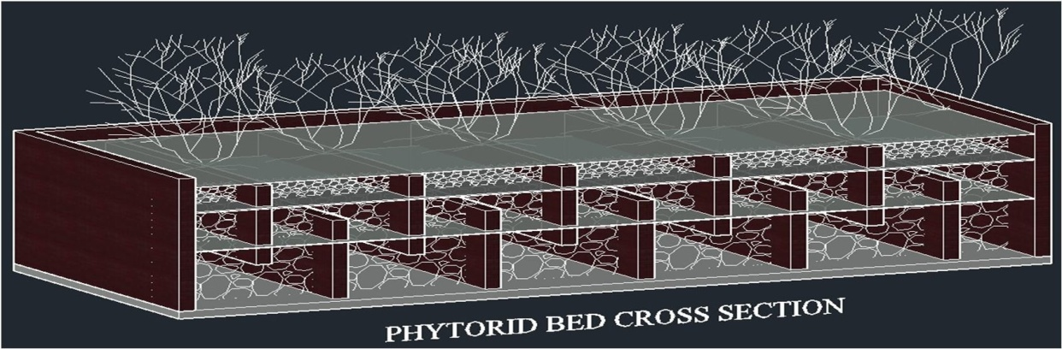

Materials required for Phytorid treatment plant

Sr.No. | Material | Quantity | Cost (Per Unit and Total)
1 | Bricks
2 | Cement
3 | Sand
4 | Coarse Aggregates for use in concrete
5 | Aggregatesofsize180mmto200mm
6 | Aggregatesofsize80mmto 110mm
7 | Aggregatesofsize25mmto 30mm
8 | Stones for use in plum concrete of size100mm
9 | Steel
10 | Man Power
11 | Miscellaneous

Points for Tenderers

Interested Bidders are required to submit their Bids in Tender form –I (Technical Bid) and Tender Form-II (Financial Bid) attached with the notice.

- Documents as prescribed in the Tender Forms –I to be submitted for qualification in the bidding process in the Financial Bids.
- .EMD will be either submitted through DRAFT in favour of “Association for Ex Sainik School Puruleans” or by NEFT. Transaction ID for Bank Transfer must clearly be included in the Tender form I.
- Start Date of submission of Tender forms : 02.12.2022
- Closing Date of submission of Tender forms : 12.12.2022
- The completed tender forms in all respect shall be submitted physically in a sealed box kept at office of the Sainik School Purulia. The tender forms shall be submitted in one big sealed envelope containing two smaller sealed Tender forms –I & II. Tender Documents can also be sent by registered post ta the following address with the Outer Envelope having NIQ Number clearly mentioned:

Prsident
Association foer Ex Sainik School Puruleans
C/O Mr Pradip Thakur
Sainik School Purulia
PO: Sainik School
Dist: Purulia
West Bengal
PIN:723104
- The Tender Committee shall first open up Tender form-I ( Technical Bid).
- Tender Committee then shall open Tender form-II ( Financial Bid) of only successful Tenderers of Technical bid.
- Tenders will be opened by the Tender Opening Committee as per directions of the President ESSPEANS.
- The Tender Committee shall open the Tender on 16.12.2022 at the office of the Sainik School Purulia at 11AM hours.
- The participants may be present at the time of opening the Tender personally or through their representatives.
- The decision of the Tender Committee will be communicated in the Association’s website by 20.12.2022.
- The Association has the right to cancel/ defer// the entire process on suitable ground/grounds.
- Details of the ESSPEANS Account for NEFT Transfer for transferring the EMD (RS.10,000.00):

- Bank: SBI
- Branch: Purulia
- IFSC: SBIN0000160
- Account Number: 37611392172

- Payment by DRAFT to be made in favour of “Association for EX Sainik School Puruleans”.
- Terms and Conditions of Payment:
- EMD : Will be returned after Tender Opening to all Tenderers except whose Bid is Approved by the Committee.
- Payment for the Work executed will be made in following Phases:
Phase1: After inspection of Dredging Work: 10%
  - Phase2: After inspection of Civil and Masonry Work: 30%
  - Phase 3: After inspection of Specialised work including Screen, Boulders/ Stones on Phytorid Bed and Plants: 30%
  - Phase 4: Final Inspection and Successful Trial Run with Water as per Purity Standard collected in Storage Tank: 15%
  - Phase 5: Six months undisturbed run: 15%
- Plants for the Phytorid Bed will be procured after samples are approved by the Committee.

Sd/-xxxxxxxxx
President Esspeans

